Veteran centers at Washington colleges strive to gain much needed funding
By Julia Dallas

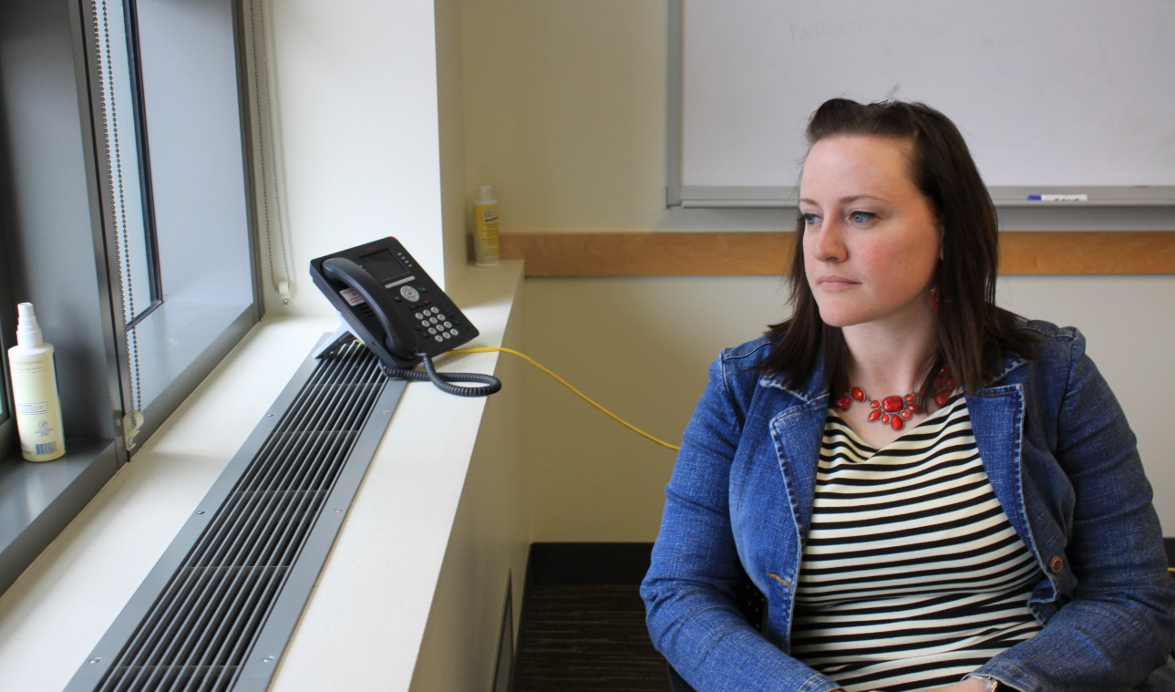

Samantha Powers, director of Student Veteran Life at the UW, reflects on the need for funding for veterans Friday. Powers served as a combat veteran in the U.S. Air Force and now dedicates her life to helping students like herself. Photo credit: Julia Dallas.

Coming home from the military and trying to find a place in civilization again can be difficult for veterans. After having a warrior mindset for so long, it can feel like you’re a stranger in your own land.
“It’s hard to leave behind the pain, the bonding, the stress, the triumph, and the awful things you maybe did, or saw,” Marny Lombard, project manager for a program called Safer Homes Suicide Aware, said.
House Bill 2513, which was passed in 2016, was made to collect data on mental health statistics at Washington colleges and then provide training on suicide awareness and other mental health related issues.
The task force created from HB 2513, discovered a few things. One was that there were over 20 thousand student veterans and dependents enrolled in Washington's community, technical and 4-year colleges.
The second was that they found the risk for suicide is significantly higher among veterans when compared to nonveterans. Lastly, they found almost half of military veterans who are enrolled in college have contemplated suicide at some point and 20 percent have planned to kill themselves.
HB 1737 was introduced to the Washington State Legislature, in January 2017, based off the findings in HB 2513.
What HB 1737 does is add a section specifically for veteran mental health that would require state universities, regional universities, and the state college to employ a mental health professional who is specifically trained in working with veterans. The bill would also give colleges funding to provide these professionals.
Dr. Laura Boye is the only mental health professional at the University of Washington who is specifically trained in helping veterans and according to Samantha Powers, director of Student Veteran Life at the UW, her case load for student veterans is building very quickly.
Boye was funded half through a private donor and the other half through the Students Assistance Fund, which ends at the end of August.
“We’ve got another pot of money that we can use for the following year, so we’re funded through August of 2019 and after that I don’t know how it’s going to look,” Powers said.
Powers hopes that they will be able to keep Boye on staff because of the ongoing therapy that is already happening with current veterans. Also, because according to Powers, the counseling center has some problems when it comes to dealing with veteran mental health.
The counseling center at the UW has a three-week wait time and sometimes the counseling that is needed for student veterans needs to be immediate.
“In some cases, we end up in these situations where there’s no one to help student veterans and so maybe they’re sent to a social worker who doesn’t have experience with veteran or combat related trauma, or military sexual trauma,” Powers said.
The counseling center’s short-term counseling model is not ideal for veterans, who usually end up needing long term therapy. As a result, veterans are often referred to outside source in the community. Powers explained this can be difficult because the veteran center in Seattle is usually extremely busy.
“Eastern Washington University doesn’t have a whole lot of student veterans and they work really well with their local vet center, which is not very busy, so they have ability to bring in an outside person,” Powers said. “Requiring people to leave campus and go somewhere else is not the same thing in Seattle as it is in Spokane. We really need someone on campus doing this.”
Lombard says that on the list of how well states meet the standard for the size of their population compared to how many mental health professionals they have treating people in the state, Washington is way down on the list. Lombard suggests Washington needs around another 240 mental health professionals.
According to Powers, last year HB 1737 went all the way through to house of appropriations and then died because of the budget associated with it. The reason the budget was so large was because it was a budget for all six state universities.
This year Ernie Tao, the legislative representative for the Associated Students of the University of Washington, worked very hard to push HB 1737 through. Yet, the redrafted bill ended up including just the University of Washington and Central Washington University, which made the budget much smaller.
“Both schools said we would be the guinea pigs, we would collect information, we would prove that it works and then hopefully it’ll expand to the other four universities and then hopefully to all 34 community and technical colleges,” Powers said.
Rep. Jim Walsh was a secondary sponsor for HB 1737 and says that even though the bill did not get passed this last week, he is sure the primary sponsor, Rep. Mike Volz, who is very passionate about the subject, will redraft the bill and try again next year.
“It is our job as representatives to keep pressure on the state agencies and to get resources to the people who need them,” Rep. Walsh said. “It is a little frustrating when bills like this keep dying.”
There is still hope the HB 1737 will be passed next year, Rep. Walsh said.

Link to HB 2513 http://apps2.leg.wa.gov/billsummary?BillNumber=2513&Year=2017&BillNumber=2513&Year=2017
Link to HB 1737
http://apps2.leg.wa.gov/billsummary?BillNumber=1737&Chamber=House&Year=2017&BillNumber=1737&Chamber=House&Year=2017

